**Artificial Intelligence**

**CS 6364.501**

**Project Report: An ontology based project to determine the dish you can prepare based on ingredients left**

**Paul Geevargheese Mathew**

**NetID:pxm142330**

**An ontology based project to determine the dish you can prepare based on ingredients left.**

Paul Geevargheese Mathew

Eric Johnson School of Computer Science, The University of Texas at Dallas.

**Problem Description**

The idea behind this include building domain based ontologies to describe the preferred dish which can be prepared by calculating the similarities between the ingredients and the dishes .The developed system mainly consist of ontology building , document formalization ,similarity calculation. First, we utilize Protégé to develop the predetermined domain ontologies in which some related concepts are defined. Then, documents concerning ingredients and dishes are formalized by means of concept trees with weights and heuristics.

**Proposed Solution**

The application works in conjunction with the knowledge base which helps in finding the right dish based on the ingredients which is the input which you give.

The application starts by asking the user to enter the ingredients .Base on the input , the application will give you a dish which can be prepared and the restaurant where you can sell the dish based on the input and it will also show you the route based on the heuristics. Thus the application helps in predicting the destination and route.

**Implementation Details & Solutions**

Following things are implemented in my logical agent

**Informed Search :** the informed search I will be using is A* . Time is one heuristic and nutrition value is another heuristic. To make the intelligent system more responsive we can add more heuristic to it.

**Domain Knowledge Creation** : OWL for knowledge representation. For ex if you want to represent that the meat is used by the dish , in owl we will represent it as

*<!-- http://www.semanticweb.org/paulgmathew/ontologies/2015/2/untitled-ontology-2#conatins -->*

*<owl:ObjectProperty rdf:about="&untitled-ontology-2;contains">*

*<rdfs:range rdf:resource="&untitled-ontology-2;Meat"/>*

*<rdfs:domain rdf:resource="&untitled-ontology-2;dish"/>*

*</owl:ObjectProperty>*

**Architectural Diagram:**

Ontology(Protege)

Jena

Dish

A*

.

**Ontology Details:**

**Class:** Dish

Ingrediants

RecipeType

CookingMethod

**SubClasses:**

**Dish (main ones):** Appetizers, SteamedAppetizers,CanapesAppetizers,DeepFriedAppetizers,GrilledAppetizers, BeansGrainsLegumes,BreadGrainsLegumes.

**Ingredients (main ones):**Bread,Dairy,DryFruits,Flour,Fruit,Meat,Nuts,Poultry,Spices,Vegetable.

**CookingMethod(MainOnes):**Baking,BasicAndEasy,Braising,Curing,Frying,GrillingAndBarbequeing, Pickiling,Poaching,Roasting,SousVide,Stewing,Stirfrying.

**RecipeType(MainOnes):**Exclusive,Fast,GlutenFree,Healthy,Kosher,MakeAhead,NoCook,StaffFavourite, Vegetarian.

**Object Properties:** contains_ingrediants,has_cooking_method,has_recipetype,present_in

**Data Property :** Calorie,cook_time,difficulty_rating,Location,name.

**JavaProgramSpecs:**

**Search Algorithm :** A* Algorithm

Admissible Heuristics : 1.Shortest Distance

2. Popularity of the road. Here each path will be given a severety level score out of 10. The edge having least severity score is more popular.

**Map Used for A\***

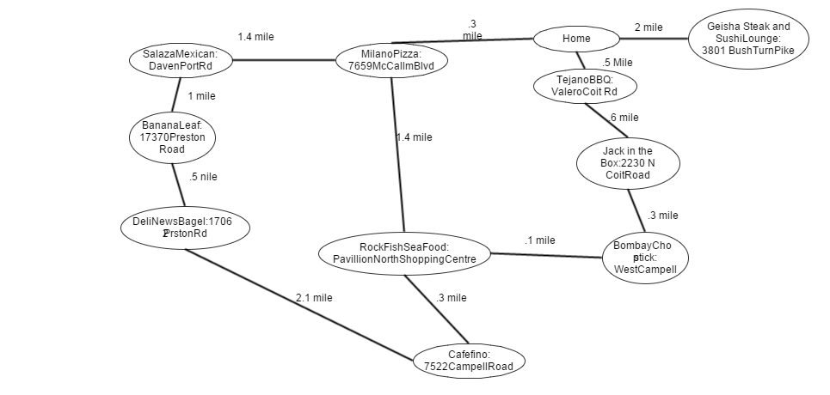

**Example Scenario,Input and Output :**

**Scenario1:** Here user will enter the ingredients he has and based on that he will get the output what dish he can make with it and where he can sell it.

1.Choose the type of ingrediants: choose Vegetable ie : option 2

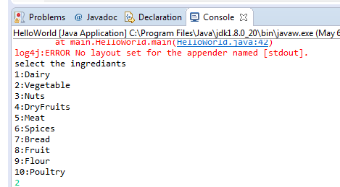

2.Choose Potato from Vegetable ie option 2

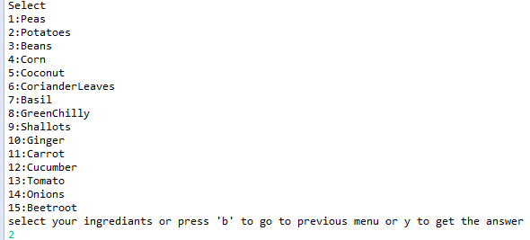

3.Selecting Onions i.e option 14

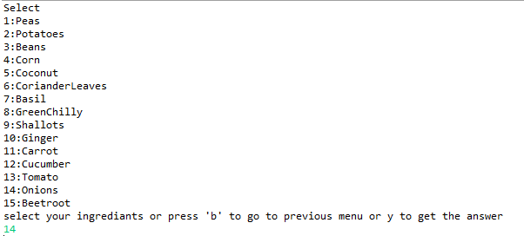

4. pressing ‘y’ to get the desired dish

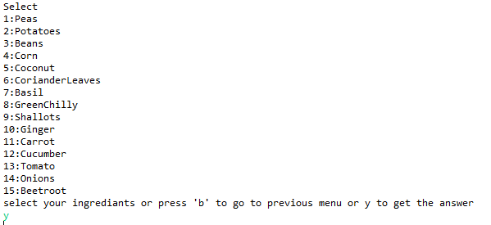

5: Screen shot of output. It will show both the sparql output and the normal output along with the route to reach destination from home based on the admissible heuristic.

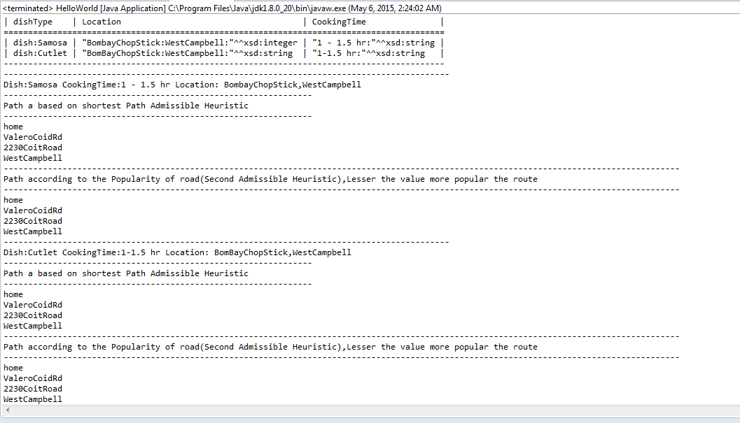

**Scenario2:**

1.Choose the type of ingredients: choose Meat ie : option 5

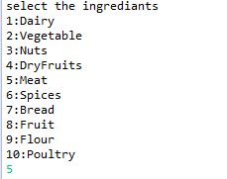

2.Choose shrimp from meat .option 1

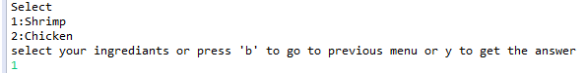

3.Choose y to get the output

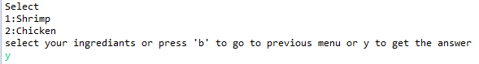

4. Screen shot of output. It will show both the SPARQL output and the normal output along with the route to reach destination from home based on the admissible heuristic.

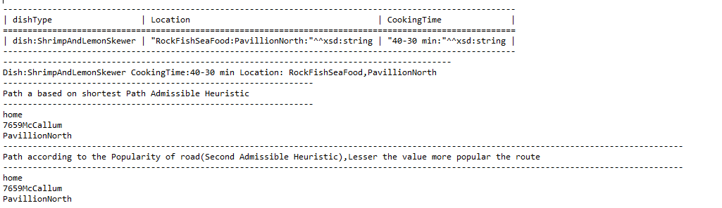

**Programming Tools(including third party software tools used)**

Apache Jena API

Eclipse

Protégé

**Problems Encountered**

While working with the project , it was very hard to come up with the proper heuristic values. Also initially faced problems regarding querying of SPARQL.

**Pending Issues**

I didn’t face any issues while working with the project , only issue facing is the API issue related to the log4j pattern layout.

**Future Scope**

* The application can be developed on mobile platform also.
* Here you can put more constraints regarding what kind of food to prepare an all.
* The same pattern can also be used where you can sell the dish based on the demand.
* Additional categories can be added.